NATURE QUIZ

WINTER
- The weather in winter is _ _ _ _ 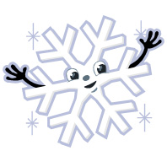and we have _ _ _ _.
- F_ _ _ _ _ _ and _ _ _ _ _ don´t grow.
- _ _ _ _ _ _ _ sleep or fly to Africa:

-.......................................................................... are in the house or outside.
- ............................... fly to Africa.
-....................................................... sleep.
- We can 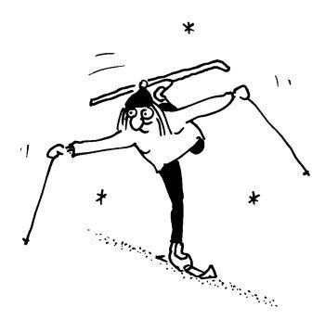 _ _ _, 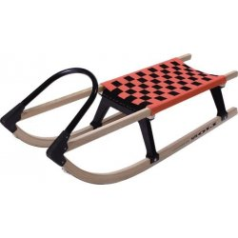 _ _ _ _ _ and _ _ _ _ a _ _ _ _ _ _ _ .
- We wear _ _ _ _ c_ _ _ _ _ _ for example: ...............................................................
- We have Ch_ _ _ _ _ _ _ in winter. We 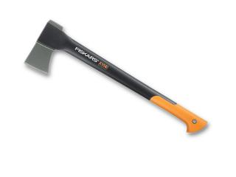 _ _ _ or _ _ _ trees.

SPRING
- In spring flowers and trees _ _ _ _.
- Animals 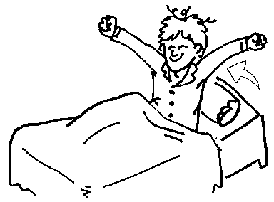 _ _ _ _ _ _ and birds come back from _ _ _ _ _ _.
- _ _ _ _ _ _ _ _ _ _ _ are born, for example chicken, lambs, ducks.
- We can plant ......................................................................................in the gardens.
- The weather is warm, the  _ _ _ shines but it is cold.
- White spring flower is _ _ _ _ _ _ _ _.

NAME: .....................................................................
.....................................................................

